# RiskProfiler Wordpress Architecture

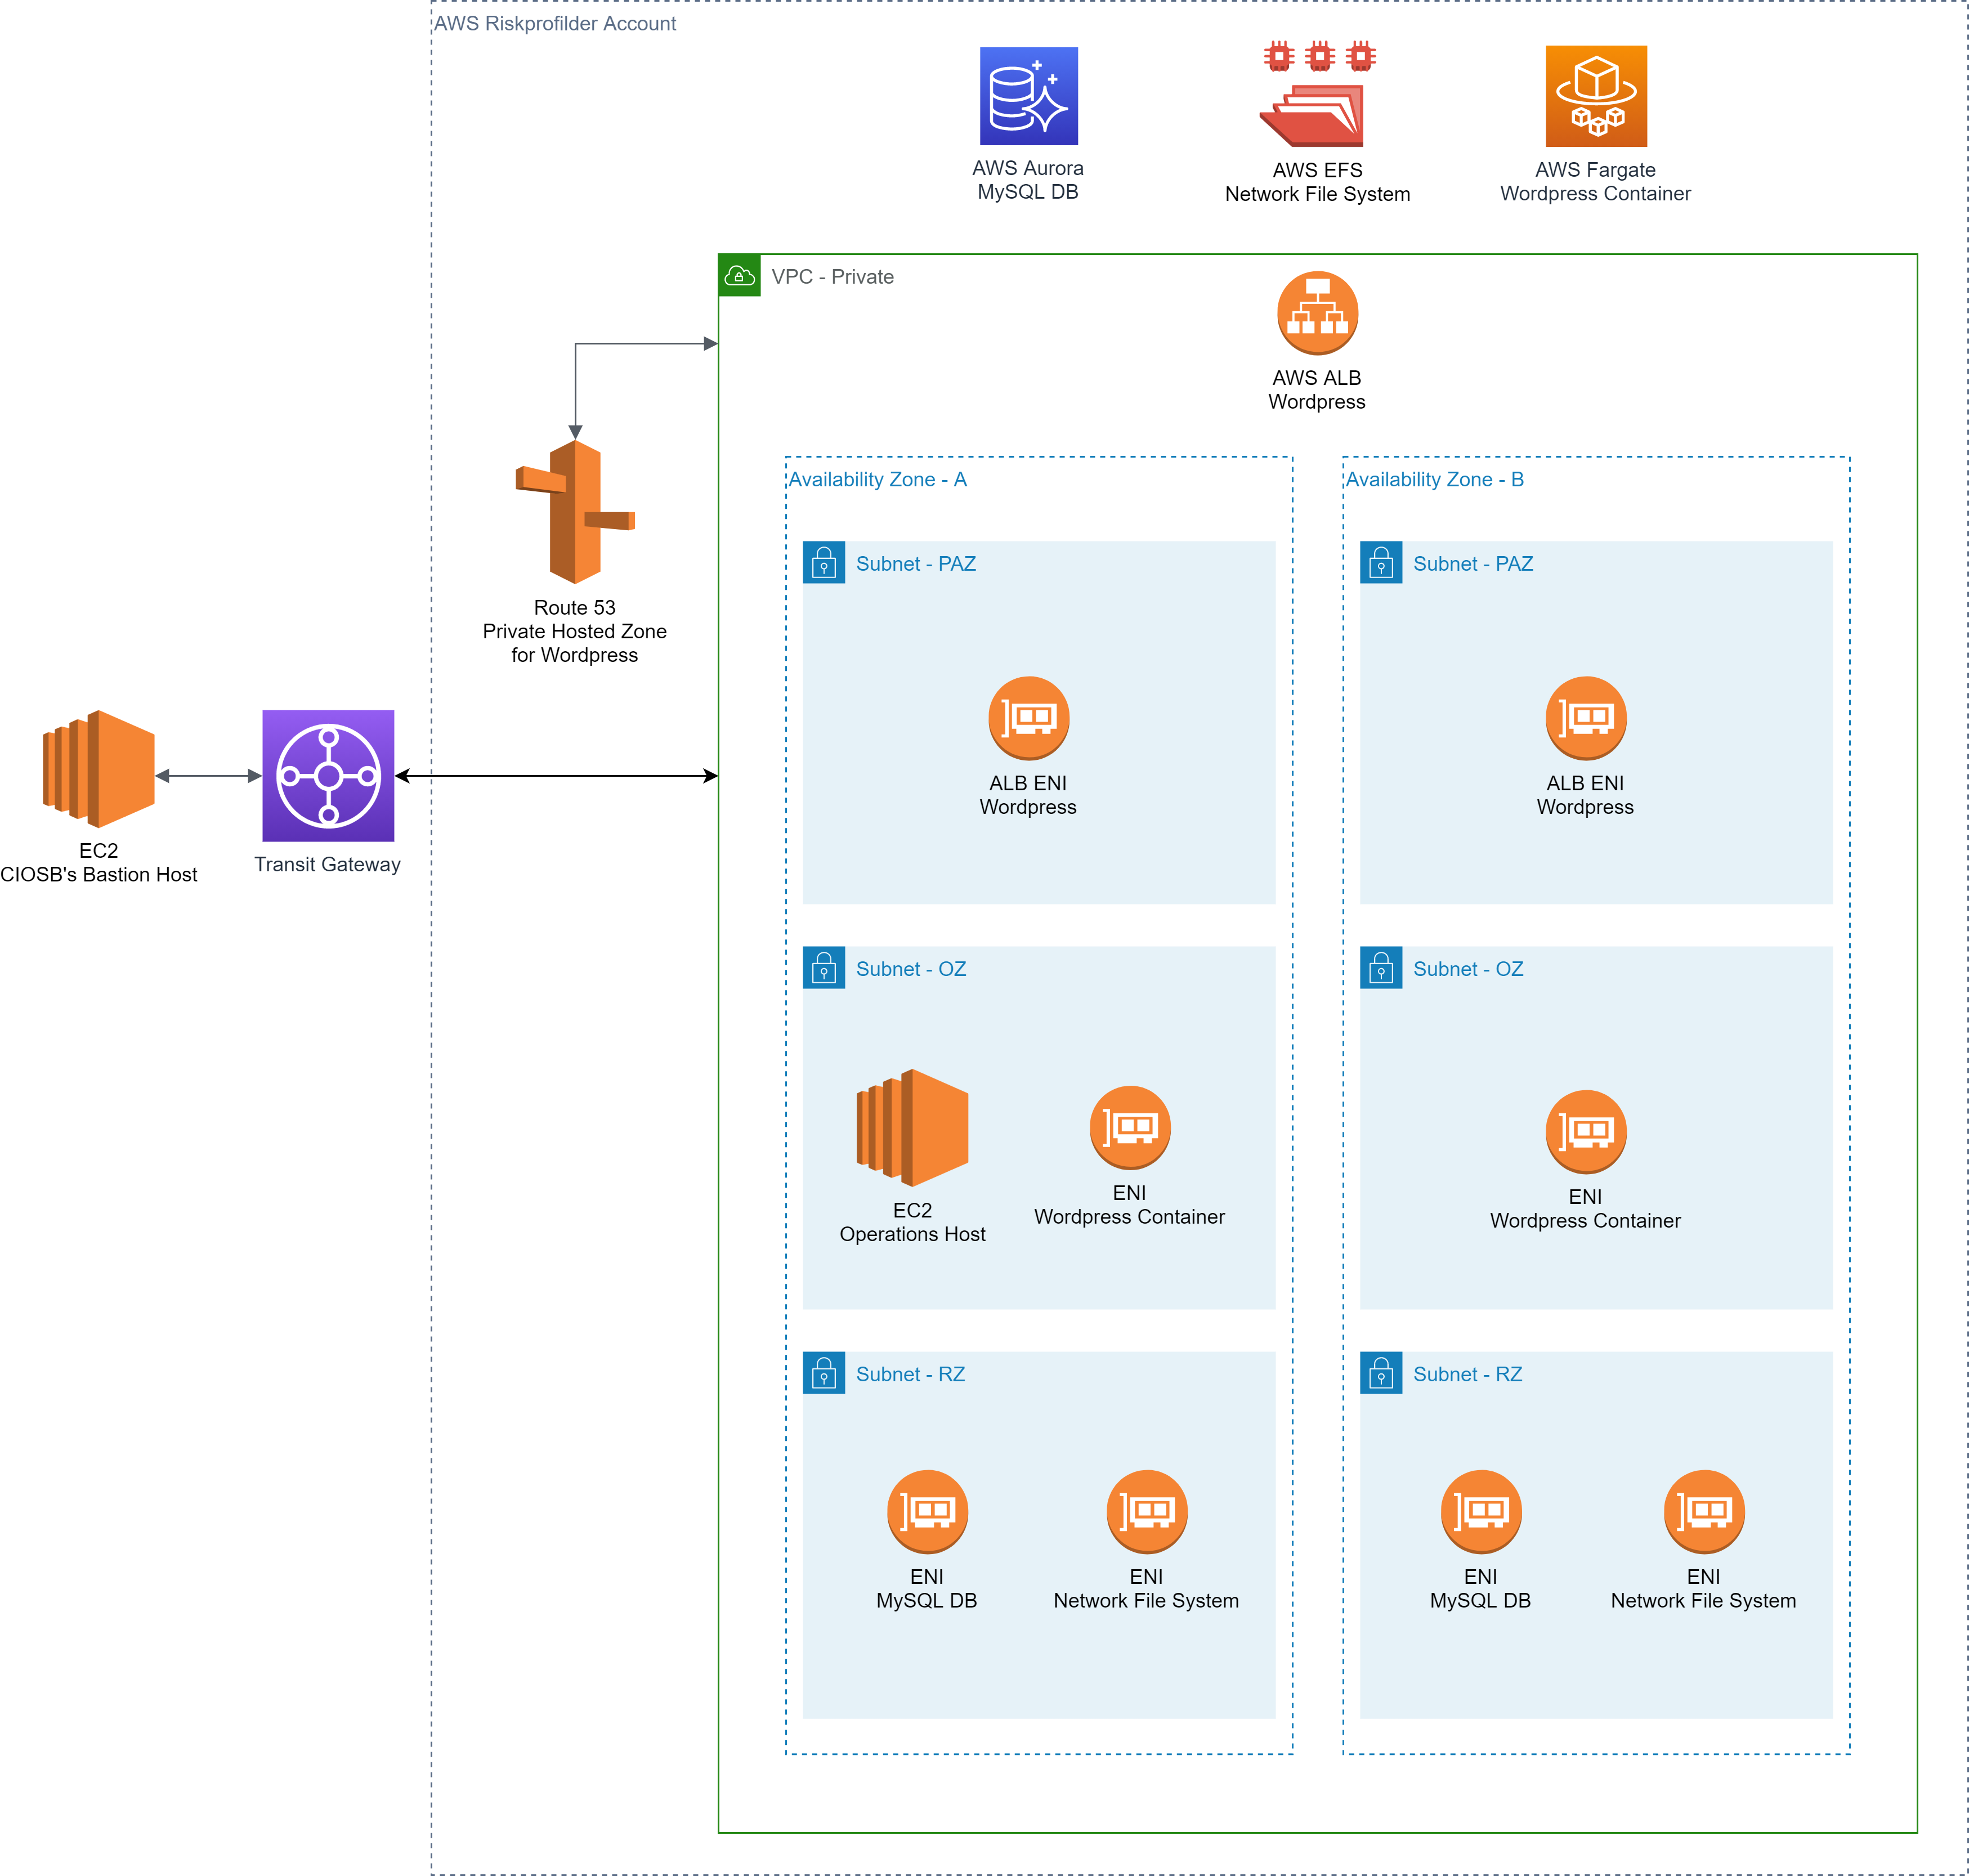

**AWS Aurora MySQL DB:** The database used by Wordpress. This is an AWS managed service and the network interfaces to access this database are located in the RZ subnets.

**AWS EFS Network File System:** Network file storage used by Wordpress to store files that need to persist when the Docker container is destroyed. This is an AWS managed service and the network interfaces to access the file system are located in the RZ subnets.

**AWS Fargate Wordpress Container:** AWS container service for running Wordpress Docker container. The network interfaces for this container are located in the OZ subnets.

**AWS ALB Wordpress:** The Docker container for Wordpress uses a random IP when it’s brought up. The IP of the container is registered with the ALB. This provides a consistent endpoint for accessing Wordpress. The network interfaces for this ALB are located in the PAZ subnets.

**EC2 Operations Host:** An EC2 instance for accessing Wordpress. Wordpress is not publicly accessible, and it can only be accessed by resources inside the VPC.

**Route53 Private Hosted Zone for Wordpress:** Wordpress needs to be accessed at the same URL as in production. The Private Hosted Zone enables implementing DNS split-view. This means accessing Wordpress URL will reach different endpoints depending on whether it’s accessed from inside or outside of VPC.

**EC2 CIOSB’s Bastion Host:** Resources inside a VPC can only be accessed through Bastion hosts. This EC2 instance enables access to Operations Host EC2.

**Transit Gateway:** Gateway for routing traffic between VPCs in different accounts.